**Assignment -2**

**PHARMACY DATA SETUP**

|  |  |
| --- | --- |
| **Assignment Date** | **28 September 2022** |
| **Student Name** | **A. L. MANIKANDAN** |
| **Student Roll Number** | **812719104020** |
| **Maximum Marks** | **2 Marks** |

**1.Sales by location**

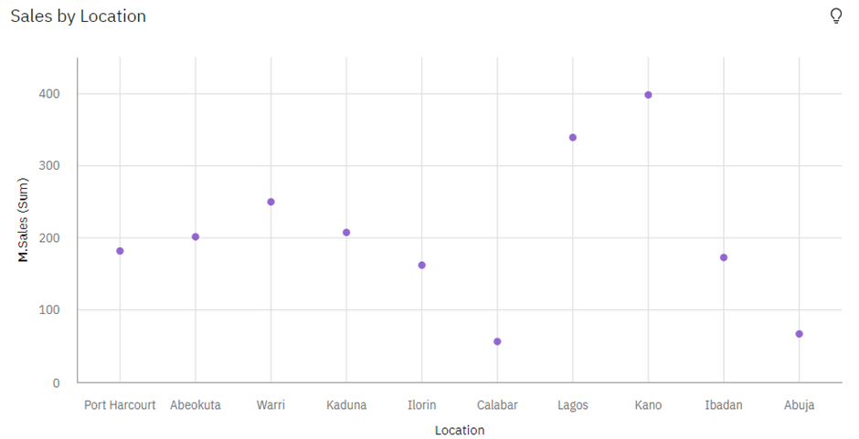

**2.Received Inventory by Warehouse Locations**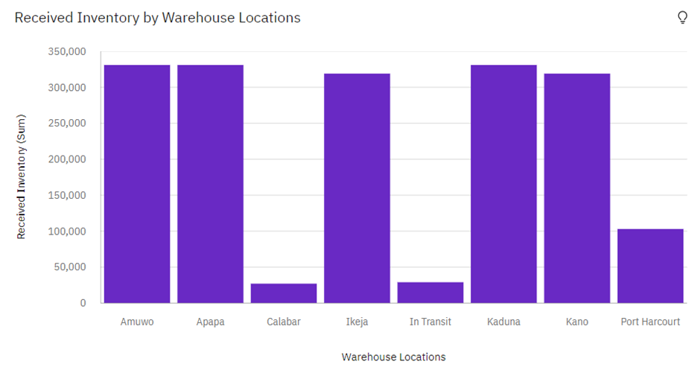

**3.Received Inventory and Actual by month**

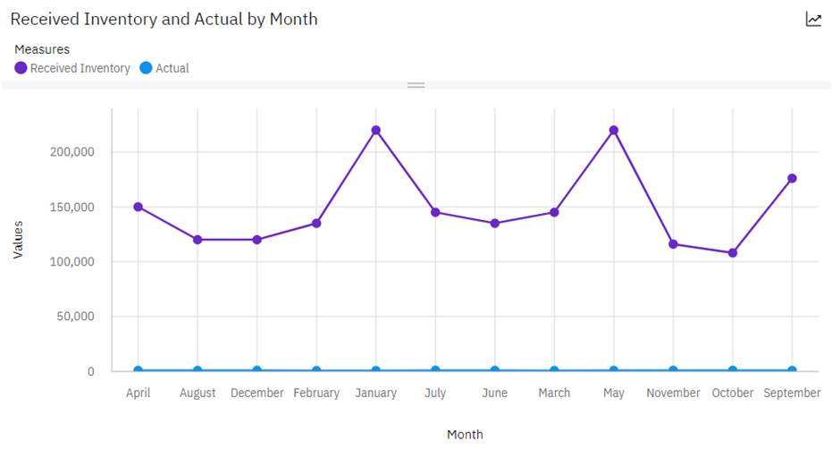**4.Sales by Sales Rep**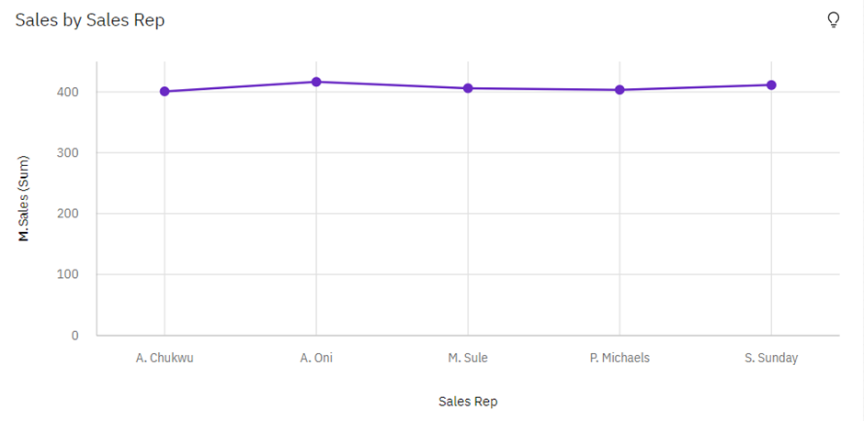

**5.Monthly Sales**

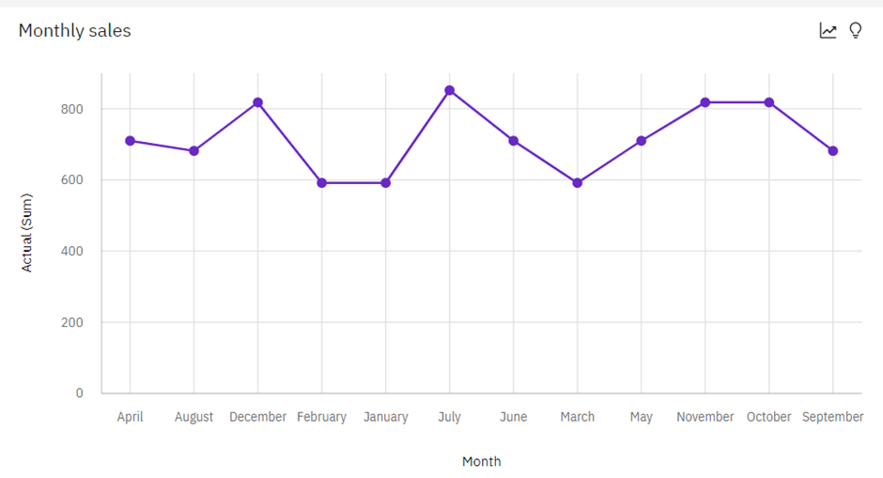

**6.Sales Trend**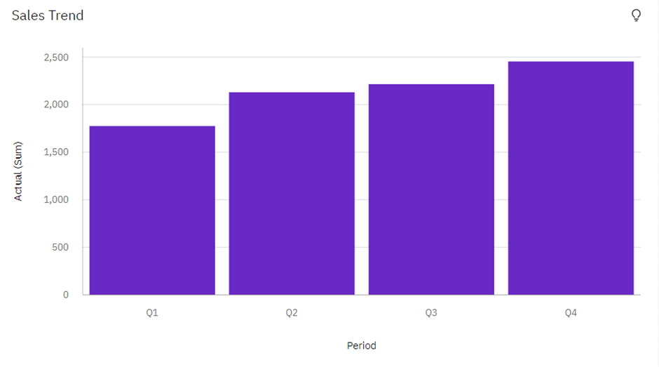

**7.Inventory Stock by Warehouse Location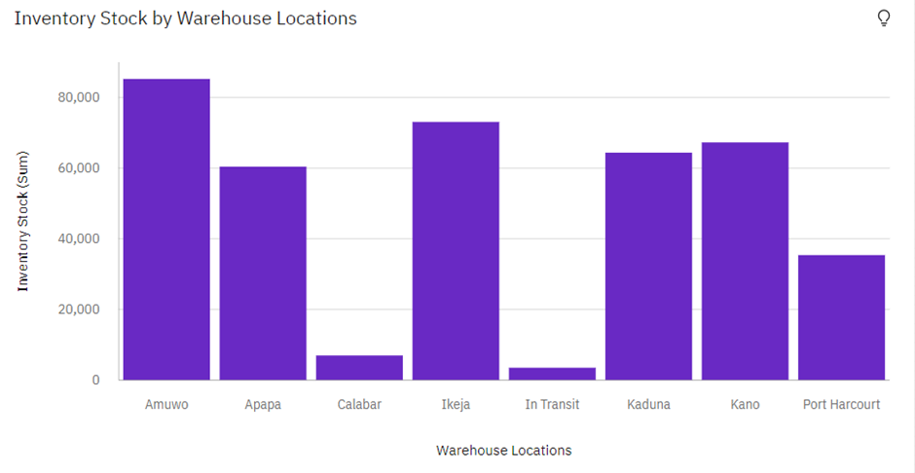8.M.Sales by customer**